# Introduction to Linux

This lab will reinforce your knowledge of the basic command-line interface functionality and provide a solid foundation from which you can continue to learn about new commands and capabilities within the Linux shells.

## Objectives

In this lab, you will:

* In the bash shell, run the man program for the first time
* In the bash shell, search the man page library to find a man page of your desired keywords

## Exercise 1: Explore the Sections of a man Page

In this exercise, you will use a bash terminal to view the Linux standard help system. This is generally referenced as manual pages, or man pages for short.

### Steps:

1. Open the manual page for the man program by typing the following command and press ENTER:

man man

1. Identify the major sections of a man page by looking for the header to the far left of the terminal (as shown in the following figure).  
   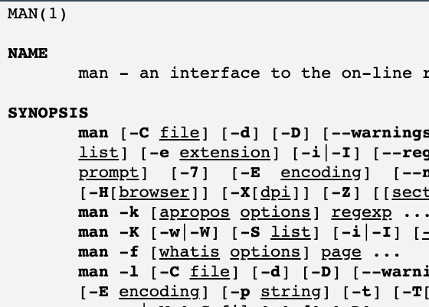

*Note*:

You can move in the man pages by pressing up and down arrow keys.

1. A few important man page headers are below (Not all inclusive):

* NAME
* SYNOPSIS
* DESCRIPTION
* OVERVIEW
* EXAMPLES
* FILES
* OPTIONS
* SEE ALSO

1. Take note of the DESCRIPTION header, particularly the section numbers.

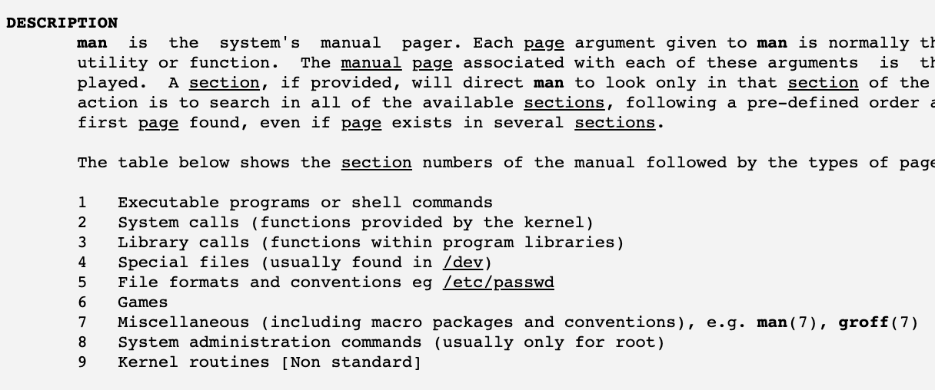

1. To exit the man page, type **q**.

## Exercise 2: Search man Pages

In this exercise, you will search for specific man pages using the **-k** parameter and then search inside of man pages for specific keywords.

### Steps:

1. Type **man -k** working into the command line to search for the keyword working in all available man pages.
2. In the display, notice there are different versions of each man page denoted by the numeric value inside of the parenthesis. These correlate to the man page table inside the description. The output of the command will be different between users. The following figure shows a keyword search for man pages using the **-k** option.  
   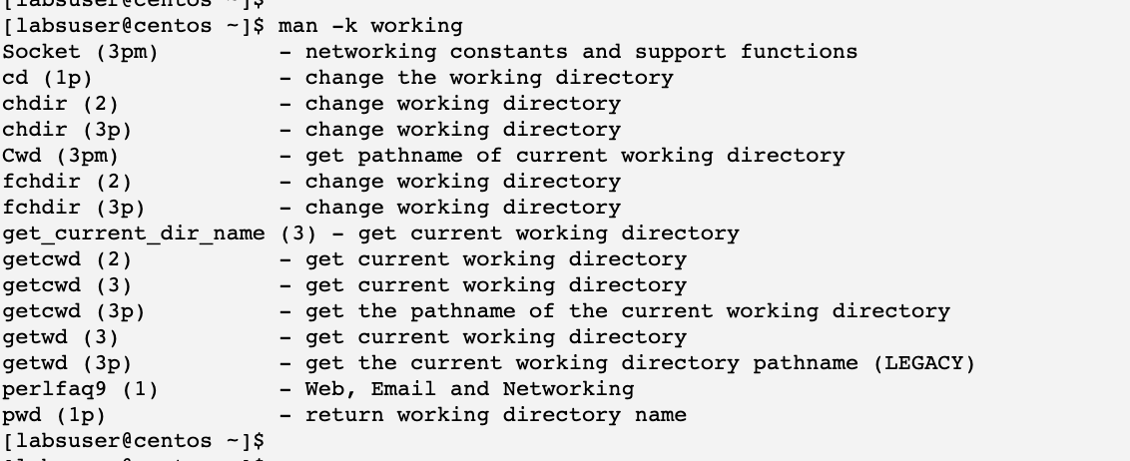
3. Type **man man** and press ENTER. When inside the man page, you will search for the keyword "file" by typing **/file** into the terminal and pressing ENTER. Note the content will scroll to where the keyword is at the top of the page. You can type n and p letters to go to the next or previous item.  
   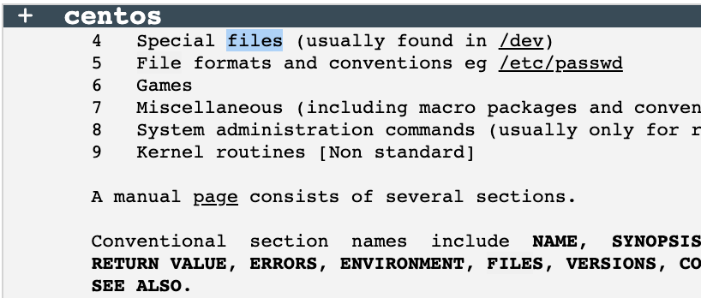
4. Type **q** into the terminal to exit the man page. You do not have to press ENTER.